# Exercises: HTML and CSS Overview

Problems for exercises and homework for the “HTML and CSS” course @ SoftUni. Submit your solutions in the SoftUni judge system at <https://judge.softuni.bg/Contests/394/HTML-and-CSS-Overview> .

## My First Page

Create a Web Page like the following.

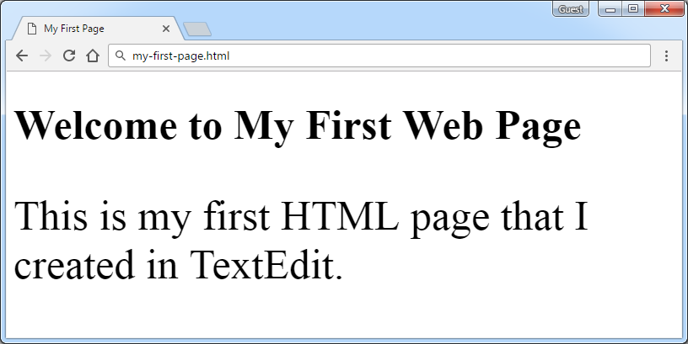

Create “**my-first-page.html**”

### Contrains

* **<h1>** tag for heading
* **<p>** tag for paragraph

## Definition Lists

Create a Web Page like the following.

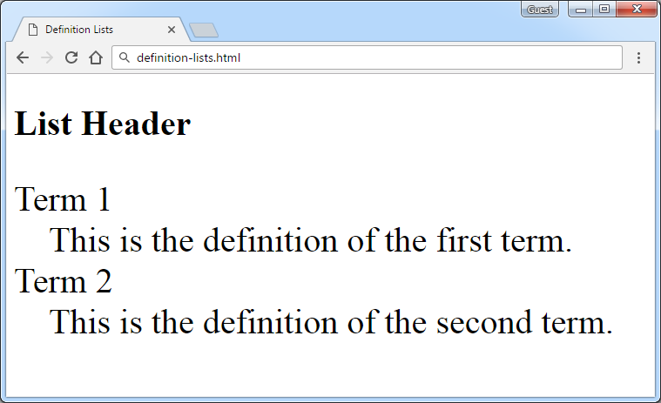

Create “**definition-lists.html**”

### Contrains

* **<h2>** tag for heading
* **<dl>** tag for definition list

## Reversed List

Create a Web Page like the following.

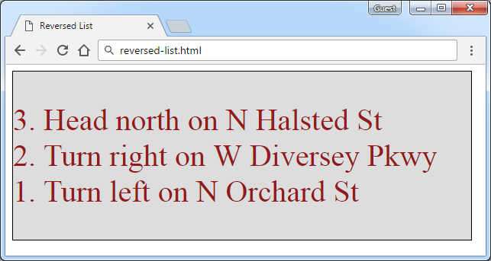

Create two files: “**reversed-list.html**”and“**reversed-list.css**”

### Contrains

* **<div>** with **id=wrapper** as a **container**
  + Background color: **#dddddd**
  + Text color: **#95191a**
  + Width container: **300px**
  + Border: **1px solid #000000**

### Hints

Use:

* **<ol>** with **reversed** attribute
  + **<ol reversed=”reversed”>**

## The Runners Home

Create a Web Page like the following using **Runners-Home.txt**.

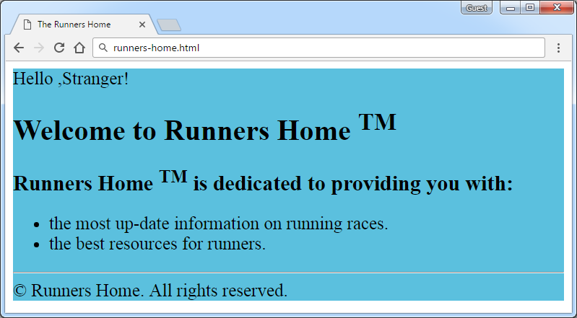

Create two files: “**runners-home.html**” and “**runners-home.css**”

### Contrains

* **<div>** with **id=wrapper** as a **container**
  + Background color: **#5bc0de**

**Hints**

Use:

* **<h1>** and **<h2>** tags for headings
* **<sup>** tag for **superscript text**
* **<p>** tag for paragraphs
* **<ul>** tag for list items
* **<hr />** for horizontal line
* **<footer>** tag for copyright part + **&copy;** for copy right symbol

## Book Story

* Create a Web Page like the following using **Book-Story.txt**.

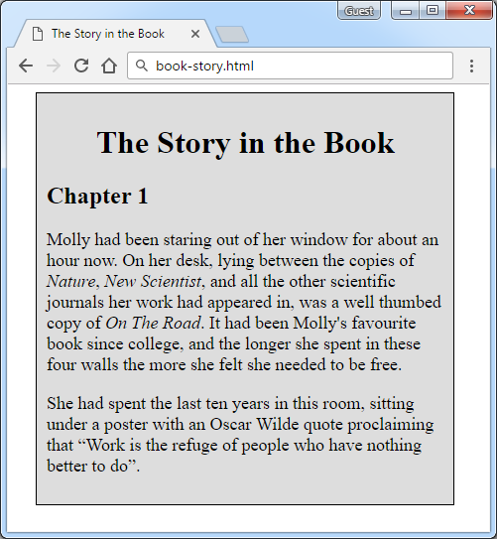

Create two files: “**book-story.html**”and“**book-story.css**”

### Contrains

* **<div>** with **id=wrapper** as a **container**
  + Width container: **300px**
  + Background color: **#dddddd**
  + Border: **1px solid #000000**
  + Margin Left**: 20px**
  + Padding**: 10px**
* **<p>** tag for paragraph + **font-size: 18px**
* **<em>** tag for italic text

### Hints

Use:

* **<h1>** tagfor heading + **center it**
* **<q>** tag for quotation text
  + **q::before {  
     content: open-quote;  
    }**
  + **q::after {   
     content: close-quote;  
    }**

## *World Cup News

Create a Web Page like the following using **World**-**Cup-News.txt.**

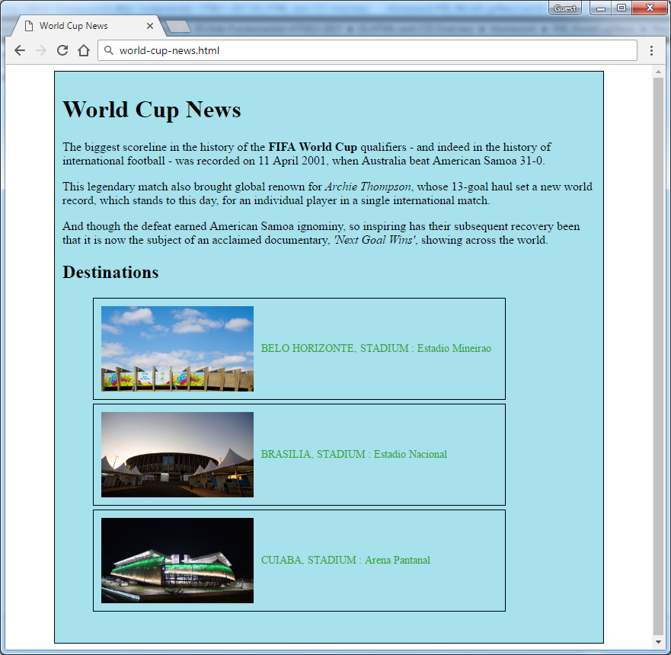

Create two files: “**world-cup-news.html**” and “**world-cup-news.css**”

### Contrains

* **<div>** with **id=wrapper** as a **container**
  + Width container: **700px**
  + Height container: **730px**
  + Border: **1px solid #000000**
  + Center the **container**
  + Padding**: 10px**
  + Background color: **#A6E1EC**
* **<h1>** and **<h2>** tags for headings
* **<p>** tag for paragraph
* **<strong>** tag for **bold** text
* **<em>** tag for **italic** text
* **<img>** tag for images
  + Width: **200px**
  + Margin Right: **10px**
  + Vertical Align: **middle**
* **<span class=”text”>** for the text next to images
  + Text color: **#2EA620**
* **<li>** tag
  + Width: **520px**
  + Padding: **10px**
  + Margin Bottom: **5px**
  + Font Size: **14px**